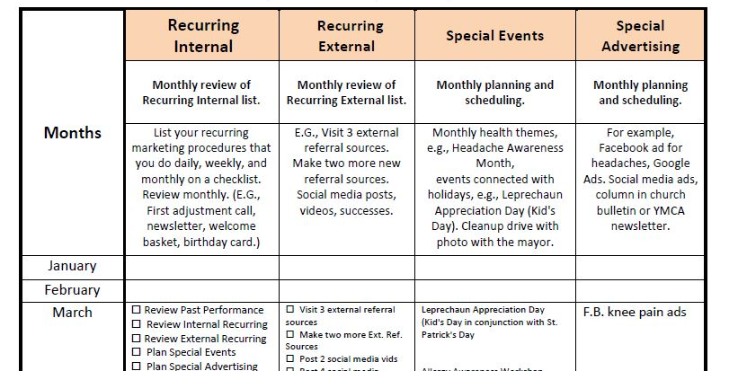
I think this image should be April, May and June.

Spring Marketing Calendar
  - The Need for Marketing Never Goes Away
(The need for marketing NEVER goes away,no matter how busy you are. So reminders are useful! Updated and reissued newsletter from 2023!)
Daylight Savings Time starts in a weeks here in the U.S (March 8, 2026). And across the northern part of our Planet, Spring begins in 4 weeks (March 20th). And not to be too pedantic, Meterological Spring has already started (March 1.) (Guess that would be autumn for you all in the southern hemisphere.)
In any event, now is a great time to plan and “giddyup” (slang – American, move faster, get going) your marketing for these upcoming active months!

The Need for Marketing Never Goes Away
No matter how full your practice is, the need for marketing never goes away.
Marketing is business and business is marketing.
Putting something valuable in the marketplace that other people want and will pay for – that is marketing. And that is your business.
The type of marketing you do varies depending on the condition and circumstances of your business. If you are just beginning a practice, you must spend a large percentage of your time and budget on marketing, especially direct response marketing. If you have built up your business, the focus of your marketing can be more on retaining your patients, creating alliances, and world-class customer service and outcomes.
Marketing covers a broad spectrum of activities, but all are, or should be, designed to generate new patients and keep the ones you have.
Trends for the future indicate that, in the end, the best and surest marketing will be customer services and outcomes. The communication channels are so packed and manufactured that your messages will get lost unless you have millions to spend. And now we have AI marketing – ads that robots put together.
THEREFORE, THE BEST MARKETING WILL ALWAYS BE PERSONAL – relationship based. You and your people -- authentic and interested in your patients and the individuals in your community – delivering extraordinary service and outcomes.
Marketing Plan
Practically speaking, it helps to plan your marketing.
Plan your work and then work your plan, right? So, I have attached a sample marketing plan (link below at the end of the blog article) to help you outline what to do. It is a sample and gives structure to managing your marketing. We’ve used one like this for years, and it works. Make your own and customize it to fit your needs.
And stay tuned for a new service we will offer to help you with your marketing.
But for now, Happy Spring!
Spring Forward!
Ed
*Contact me for help! Email: Ed@pmaworks.com, or 414-332-4511.
*Sample marketing calendar Where do I find this calendar?

